**Microservices Architecture: A Brief Overview**

**Microservices architecture** is an architectural style that structures an application as a collection of small, independent services, communicating over well-defined APIs.

**Key Characteristics**

* **Decentralized:** Each microservice is autonomous and can be developed, deployed, and scaled independently.
* **Loosely Coupled:** Services have minimal dependencies on each other.
* **Organized around Business Capabilities:** Services are designed around specific business functions.
* **Polyglot:** Different services can use different technologies, languages, and frameworks.
* **Containerization:** Often used with containers (e.g., Docker) for easy deployment and management.

**Advantages**

* **Scalability:** Individual services can be scaled independently, allowing for efficient resource utilization.
* **Flexibility:** New technologies can be adopted for each service without affecting the entire application.
* **Faster Development:** Smaller, independent teams can work on different services concurrently, speeding up development.
* **Resilience:** If one service fails, it doesn't bring down the entire application.
* **Maintainability:** Easier to maintain and update smaller codebases.

**Disadvantages**

* **Complexity:** More complex to design, develop, and manage due to the distributed nature of the system.
* **Increased Overhead:** Requires more infrastructure and resources for managing multiple services.
* **Debugging Challenges:** Debugging can be more difficult due to the distributed nature of the system.
* **Network Latency:** Communication between services can introduce network latency.
* **Data Management:** Managing data consistency across multiple databases can be challenging.

**Comparison with Monolithic Architecture**

Microservices architecture is often compared to monolithic architecture, where an application is built as a single, unified unit.

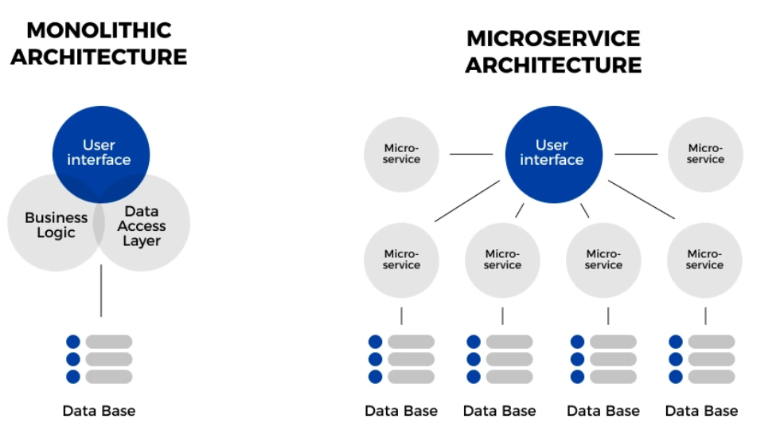

**In summary**, microservices architecture offers significant advantages in terms of scalability, flexibility, and resilience, making it well-suited for complex and evolving applications. However, it also introduces complexities that need to be carefully managed.